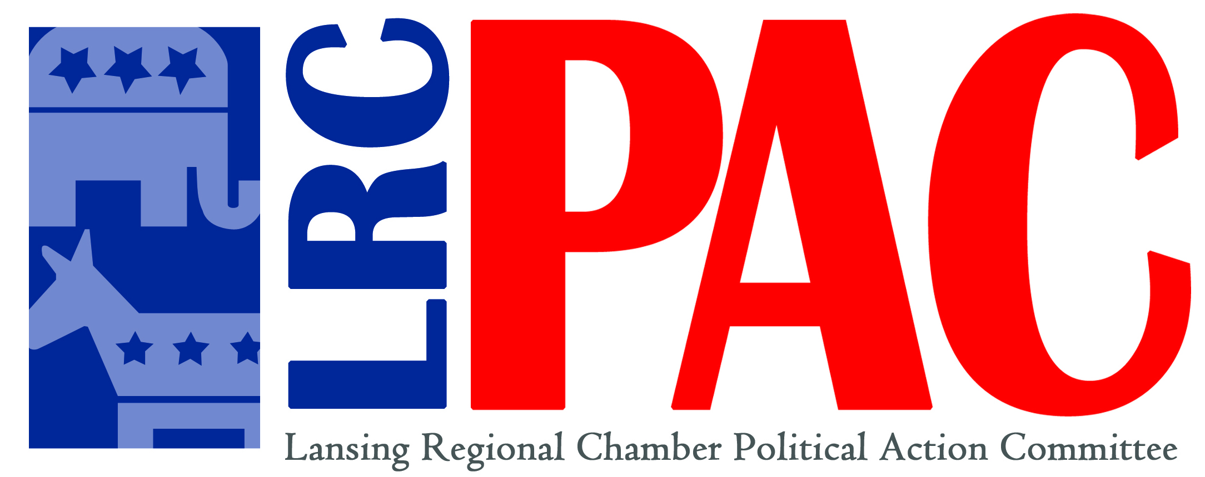

FOR IMMEDIATE RELEASE Contact: Ross Woodstock
Kolt Communications, Inc.
February 24, 2015 517-706-0001/517-410-7636
Ross@Koltpr.com

Lansing Regional Chamber to Offer Campaign
Workshop to Potential Candidates

The Lansing Regional Chamber Political Action Committee (LRC-PAC) “Make a Difference, Run for Office” workshop offers an opportunity for potential candidates for office to learn from the experts ways to put together a winning political campaign and the demands and responsibilities of being an elected official. The workshop will feature a representative from the State Bureau of Elections, a campaign strategist and current elected officials. These experts will share their experience and insight with participants.

Monday, March 23 2015
8:30 a.m. to 12:00 p.m.
Lansing Regional Chamber Office
500 East Michigan, Suite 200, Lansing
(Free parking available behind building)

Most cities in the Greater Lansing region will be holding elections for city council in November 2015. This event will allow those who are interested in running for office a chance to interact with those who know how to win a race. The LRC-PAC wants to equip pro-business and pro-economic growth candidates with the tools to pull off a successful campaign.

There is no charge to attend. For registration, please contact Karrie Groomer at 517-487-6474 or kgroomer@lansingchamber.org.

LRC-PAC is the nonpartisan political action committee of the Lansing Regional Chamber of Commerce representing 900 businesses in Lansing and over 1,300 businesses in the tri-county region. The LRC-PAC objective is to endorse candidates committed to the principles of free enterprise, economic growth and a pro-business philosophy.
###

