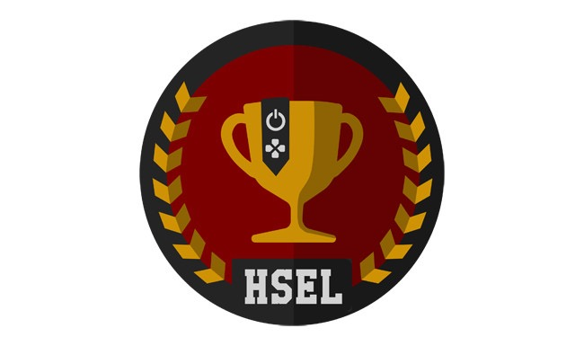
Michigan High School Athletic Association
1661 Ramblewood Drive
East Lansing, MI 48823
Attn: Executive Council

To Whom It May Concern,

On behalf of the _____________________________________, I am pleased to offer this letter of support for the MHSAA to sponsor eSports (competitive video gaming). The growth of Esports at the university level that includes the rewarding of scholarships to students can no longer be ignored. It is time for Michigan high schools to recognize Esports as a legitimate athletic activity that provides students with many opportunities to develop various skills and qualities such as: critical thinking, teamwork, inclusion and technological proficiency.

Please consider making Esports a sponsored activity. The MHSAA can be an early adopter of a trend that is only expected to grow exponentially in the next few years. I welcome any questions you may have regarding this matter.

Sincerely,

Your Name

Title:
Name of Organization:

